New diaphragm seal for
process temperatures up to 450 °C

Klingenberg, March 2022. WIKA has tailored a new diaphragm seal to applications with very hot media. Model 990.45 is suitable for temperatures up to 450 °C.

The high-temperature diaphragm seal is used in refineries, among other places, to enable precise measurement even at high process temperatures. It is combined with a capillary and a standard measuring instrument, without any additional cooling element, to form a measuring system. Its lower body, including flange connection, is made of a single piece, which minimises the risk of leakage. Customer-specific sealings simplify the connection of the diaphragm seal to the respective process.

The new instrument can be fitted with fixtures for a lifting aid. Thus, it can be moved and installed effortlessly. A flushing connection integrated in the lower body also enables the diaphragm seal to be cleaned without having to take it apart first.

Number of characters: 871
Key word: 990.45

Manufacturer:
WIKA Alexander Wiegand SE & Co. KG
Alexander-Wiegand-Straße 30
63911 Klingenberg/Germany
Tel. +49 9372 132-0
Fax +49 9372 132-406
vertrieb@wika.com
www.wika.de

WIKA company photograph:
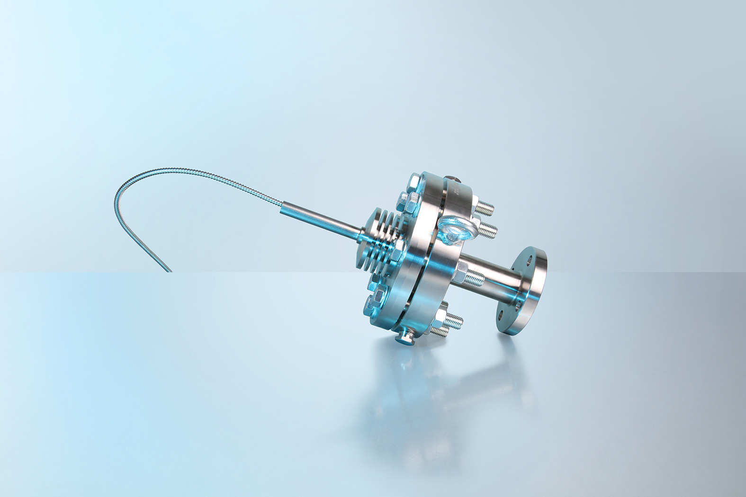
Model: 990.45

Edited by:
WIKA Alexander Wiegand SE & Co. KG
André Habel Nunes
Marketing Services
Alexander-Wiegand-Straße 30
63911 Klingenberg/Germany
Tel. +49 9372 132-8010
andre.habel-nunes@wika.com
www.wika.de

WIKA press release

