Pre-volume deflagration flame arrester,
also with IECEx approval

Klingenberg, July 2021. As the only one of its kind so far,
the pre-volume deflagration flame arrester for pressure measuring arrangements from WIKA has an IECEx approval in addition to its ATEX approval. It is thus gaining broad international acceptance.

The safety device (model 910.21) fulfils the requirements of the harmonised standard EN ISO 16852:2016 “Flame arresters …”. WIKA combines them with Ex-approved measuring instruments and diaphragm seal systems to form a fixed unit. Such a measuring arrangement is suitable for mounting to zone 0.

The pre-volume deflagration flame arrester prevents a potential passage of the flame from the instrument into the process side, in the event of a failure. A marking on the measuring arrangement indicates the point at which the protected side begins.

Number of characters: 776
Key word: Pre-volume deflagration flame arrester

Manufacturer:
WIKA Alexander Wiegand SE & Co. KG
Alexander-Wiegand-Straße 30
63911 Klingenberg/Germany
Tel. +49 9372 132-0
Fax +49 9372 132-406
vertrieb@wika.com
www.wika.de

WIKA company photograph:
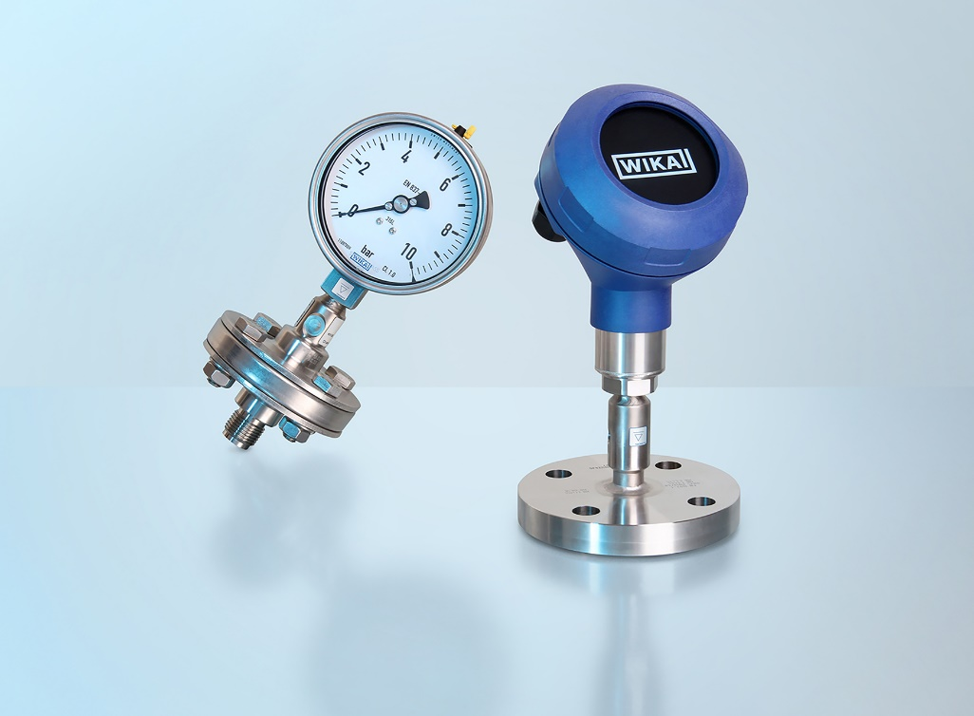
Model: 910.21

Edited by:
WIKA Alexander Wiegand SE & Co. KG
André Habel Nunes
Marketing Services
Alexander-Wiegand-Straße 30
63911 Klingenberg/Germany
Tel. +49 9372 132-8010
Fax +49 9372 132-8008010
andre.habel-nunes@wika.com
www.wika.de

WIKA press release

