Digitalised safety
with new diaphragm seal system

Klingenberg, June 2021. The requirements of digitalised sterile processes are met by a new diaphragm seal system from WIKA with process transmitter, diaphragm monitoring and HART®7 protocol. The model DMSU21SA has approvals for all common hygiene standards and is available in a version with explosion protection.

The complete measuring arrangement is parameterised via a single cable outlet and HART®7. The communication protocol transmits the measured values as well as the alarm signal from the diaphragm monitoring. The patented safety function is based on a double diaphragm with evacuated intermediate space and a pressure switch. In the event of a rupture of the process-side diaphragm, the switch sends an immediate damage message while the second diaphragm continues to monitor the pressure.

The new diaphragm seal system measures pressures between -1 bar and 25 bar with an accuracy of 0.1 % of span. The model DMSU21SA is available with all sterile connections and the application-specific system fill fluids.

Number of characters: 994
Key word: DMSU21SA

Manufacturer:
WIKA Alexander Wiegand SE & Co. KG
Alexander-Wiegand-Straße 30
63911 Klingenberg/Germany
Tel. +49 9372 132-0
Fax +49 9372 132-406
vertrieb@wika.com
www.wika.de

WIKA company photograph:
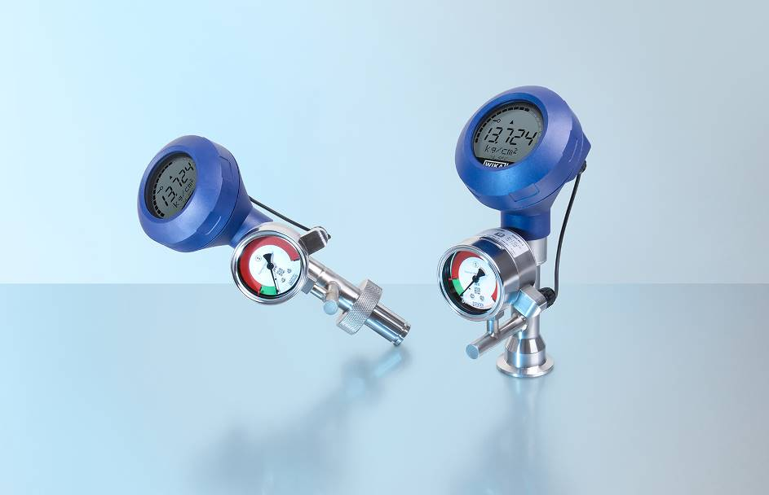
Model: DMSU21SA

Edited by:
WIKA Alexander Wiegand SE & Co. KG
André Habel Nunes
Marketing Services
Alexander-Wiegand-Straße 30
63911 Klingenberg/Germany
Tel. +49 9372 132-8010
Fax +49 9372 132-8008010
andre.habel-nunes@wika.com
www.wika.de

WIKA press release

